METALLIC NOZZLE-MIX GAS BURNERS | MODEL : MNG

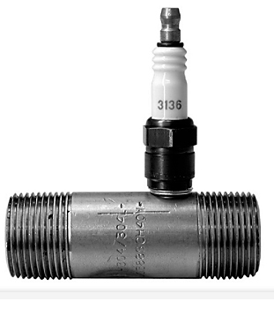
MNG Nozzle-Mix gas burners operate with a wider sability range than premix burners. Ease of installation, operation, and maintenace has been stressed in the MNG design. Body sizes from 1” to 8” are available, with two deferent styles (LP,HP) to serve a wide range of application. The “LP” version is a low pressure burner that is designed to be used between 1-16 mbar air pressures. The “HP” version requires 60mbar air pressure, and can be operated with an air gas ratio regulator.
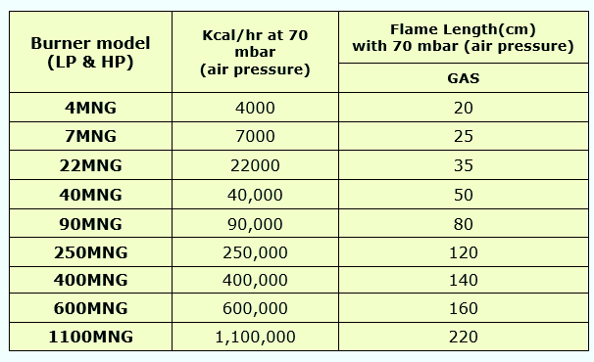
AZIN SHOLE AFROZ KIMIYA
TLE: 026-34277851 FAX: 026-34277499 WWW.ASHAK.CO.IR

“LP” Low Pressure
The “LP” version is used when only low pressure air (1-16mbar) is available. The MNG has a wider stability range. The air pressure across the burner tip can be set low,1mbar is adequate.Because a small amount of gas is pre-mixed into the air , it is important that the gas pressure be 3 to 6 times as high as the air pressure to ensure good stability. Always install a pressure tap in the air and gas lines at the burner tip to check for suitable pressures. Do not use an air/gas ratio regulator with the “LP” version unless it provide gas pressure 3- 6 times as high as the air pressure.

“HP” Burners
The “HP” versions allowing use of an air/gas ratio regulator. If air pressure is in the range where a “HP” burner can be used with a regulator, it is a better choice than the “LP”. The MNG-HP Is designed so that when the air and gas pressures are equal into the burner tip, the flame will burn with approximately 100% excess fuel which is well within the rich stability limit.This makes it easy to set the burner when using a ratio regulator. In many cases the gas adjustable valve can be left fully open, and the regulator will maintain proper air/fuel ratio. The wide stability range makes the MNG ideal for multiple burner applications. The MNG flame is visible from an observation port installation on an air inlet. Although the length of the flame can not be judged fully, it is still useful to use the observation port for setting up the burner and monitoring performance installation.
1. Install the burner in the proper position.
2. Connect air and gas lines to sources upstream of burner control valves. The air lines have to be sized as large as the burner tip thread.
3. If possible use an air/gas ratio regulator on the gas line (except the “LP”). Although the ratio stability limits are very wide on the MNG, a regulator assures the burner will run consistently if air pressure varies.
Lighting “LP”
1. Close all fuel supply lines.
2. Set the air pressure at the burner.
3. Supply an ignition source to the spark plug and open the gas until the burner lights.
4. Gas pressures 3-6 times greater than the air pressure are recommended.
AZIN SHOLE AFROZ KIMIYA
TLE: 026-34277851 FAX: 026-34277499 WWW.ASHAK.CO.IR

Lighting “HP”
4. Close all fuel supply lines.
5. Set the air pressure at the burner to 20 to 40mbar.
6. If an air/gas ratio regulator is installed, open the gas adjustable valve to 100% open. If there is no ratio regulator, set the gas pressure so that it equals the air pressure.
7. Supply and ignition source to the spark plug and open the gas valve.
8. Make flame adjustments using the adjustable valve or air valve if necessary.
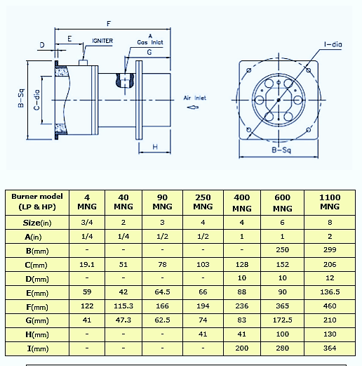
AZIN SHOLE AFROZ KIMIYA
TLE: 026-34277851 FAX: 026-34277499 WWW.ASHAK.CO.IR

