MEDIUM VELOCITY LONG FLAME GAS BURNER | MODEL : MGLK

Medium Velocity Gas burners are widely used on heat treat and melting furnaces, kilns, ovens, air heaters dryers, chemical process equipment, and other applications where superior temperature uniformity is required. These sealed–in, nozzle–mix burners for gas are stable on stoichiometric ratio, with large amounts of excess air, or with up to 50% excess fuel (provided additional air for combustion is in the furnace near the burner).
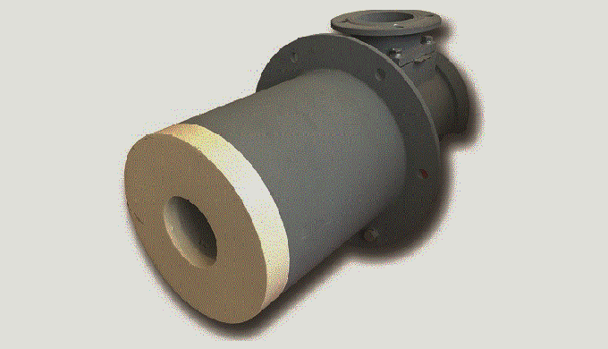

OPERATION Burners can be lighted at rich, lean, or correct air/fuel ratio then immediately turned to high fire. Required gas pressures are low for natural gas. The most common ratio control system for these burners uses a cross–connected governor. When appropriate for the application, flow balancing systems or fuel only control (see “Excess Air“ paragraph) is very satisfactory. If furnace temperatures after shutdown rise above 1000oC, pass some air through burner to prevent overheating.
LIGHTING / FLAME SUPERVISION
A pilot is normally used to light these burners. Direct spark ignition of the burner is also available. Burners accept ultraviolet (UV) scanners for monitoring pilot or main flame. A flame rod can be used to monitor pilot or main flame. When using flame supervision, an interrupted pilot is required – do not use constant or intermittent pilots. If using direct spark ignition, turn off spark after burner lights. All burners are furnished with an observation port. A lighter hole
AZIN SHOLE AFROZ KIMIYA
TLE: 026-34277851 FAX: 026-34277499 WWW.ASHAK.CO.IR

cover is supplied if a pilot is not ordered. Position of pilot, flame detector, and observation port are interchangeable as long as pilot and flame detector are mounted in adjacent holes.
EXCESS AIR
Excess air improves temperature uniformity by avoiding hot spots in front of burners, churning furnace atmosphere to reduce stratification, and creating positive furnace pressure to eliminate cold air infiltration. Excess air can give very high effective burner turn down. Thus a furnace used for high temperature work with burners firing on stoichiometric air/fuel ratio can also be used for low temperature jobs with burners firing on lean ratio.
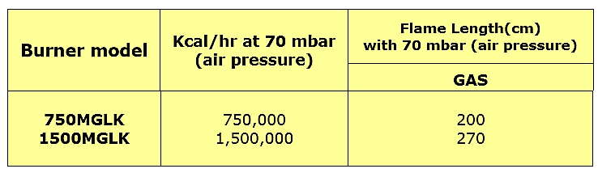
CONSTRUCTION FEATURES Air and gas inlets can be rotated in 90º intervals. Mounting plates are cast iron. For installation convenience, burner body can be separated from the mounting plate and tile assembly. But tile must be set in the wall with pilot and flame detector notches in proper location relative to intended burner body position.
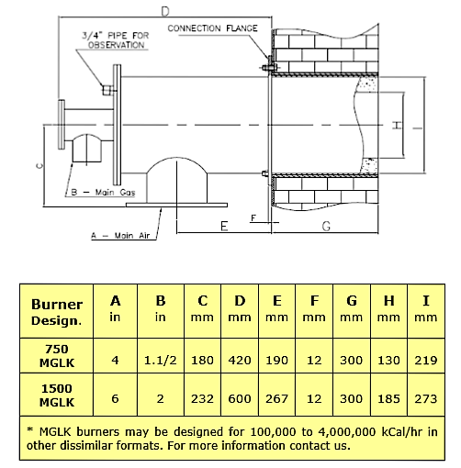
AZIN SHOLE AFROZ KIMIYA
TLE: 026-34277851 FAX: 026-34277499 WWW.ASHAK.CO.IR

INSTALLATION
1-Requirements:
a) Maximum allowable inlet pressure to the gas governor is 180 mbar. If greater than 180 mbar, an upstream pressure regulator must be used.
b) Gas supply pressure to the gas governor should be at least 14 mbar greater than the high fire burner air pressure. If less, a bleeder must be installed in the impulse line.
2-Burner Mounting:
a) WARNING: Burners cannot be rotated with respect to the mounting plate as the pilot and flame detector ports must align with notches in the plate .
3-Piping:
a) Minimize piping pressure losses. Use a minimum of elbows. Substitute 45º elbows for 90º elbows when possible. Do not use street elbows. Use pipe (not tubing) for pilot air and gas lines. 1/4˝ tubing may be used for impulse lines up to 3 m long, 1/2˝ tubing or larger for longer runs.
b) Pipe lines in a manner similar to that shown in Figure 1. Flexible connections are recommended in air and fuel lines to minimize strain from piping and thermal expansion.
c) Pilot air, gas supply connections must be made upstream of primary burner controls so that they are not affected by the zone air control and gas shutoff valves.
d) Connect impulse piping as shown in Figure 1. These piping arrangements are designed to keep air and gas flows on desired ratio at all firing rates.
e) Ratio regulator impulse line connections must be located between the zone control air valve and the manual burner air valve for multiple burner zones and downstream of the manual burner air valve for single burners.

AZIN SHOLE AFROZ KIMIYA
TLE: 026-34277851 FAX: 026-34277499 WWW.ASHAK.CO.IR

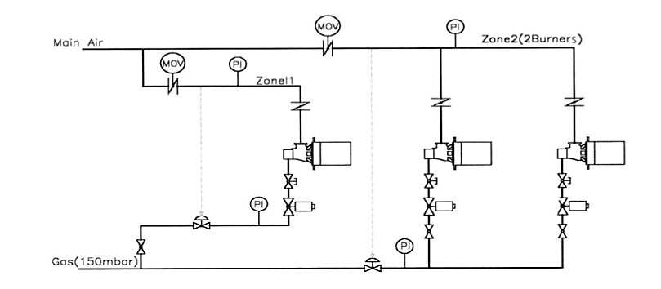
Fig. 1 Suggested Piping Arrangement for MGLK Burners

LIGHTING AND ADJUSTMENT
1-Basic:
a) All manual and automatic gas valves must be closed.
b) Open all furnace doors and flue dampers. Lock all burner air valves in full open position.
c) Start combustion air blower and check rotation.
d) Adjust damper motor/air valve linkage(s) for low and high fire.
e) Set damper motor(s) at high fire allowing furnace to purge for several minutes prior to lighting. Check motor amps with all burners at high fire. If in overload, adjust the linkage to reduce the high fire air flow.
f) Return the damper motor to low fire. Linkage must not bind.
AZIN SHOLE AFROZ KIMIYA
TLE: 026-34277851 FAX: 026-34277499 WWW.ASHAK.CO.IR

2-Light the pilots in accordance with the pilot instruction sheet:
a) Open gas adjustable valve fifty percent (ADV) from full closed position.
b) Open gas shutoff vlave(s). If burner does not light within a few seconds, close gas shutoff valve and open adjustable valve one more turn, then open gas shutoff valve.Repeat as necessary until burner lights.
c) Slowly open main air valve to high fire position, adjustable valve as necessary. d) Return control valve to low fire position,adjust gas governor for desired flame. e) Repeat steps (c) and (d) if necessary.
3-Trouble shooting: a) Gas supply pressure too high or too low (see appropriate regulator literature).
b) Impulse pressure too low to gas governor-check for dirt in line or connections, check method of connecting impulse line to air pipe.
c) Governor not controlling -check method of connecting impulse line to air pipe, check governor diaphragms (see governor literature), if bleeder is used, check orifices for dirt.

AZIN SHOLE AFROZ KIMIYA
TLE: 026-34277851 FAX: 026-34277499 WWW.ASHAK.CO.IR

