WIDE FLAME DUAL FUEL BURNER | MODEL:WFGO

This wide flame dual fuel burner features short and wide flame pattern in broad stability range. This burner is designed to fire combustion chambers that have a limited length but with sufficient width to allow the flame envelope to develop.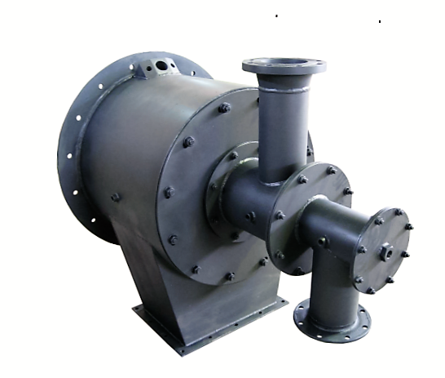
This burner has provision for gas pilot and ultraviolet flame supervision device. Both gas and oil flames are tile – stable over a fairly wide range of air/fuel ratios. The burner can be used in cold sealed-in combustion chambers with light oil or gas.
Atomizer : This burner is equipped with special type atomizer. The burner may be operated on oil or gas. Atomizing air is provided from external blower with pressure of 70mbar for light oil and 100mbar for heavy oil.
Ignition and Flame Supervision : This Burner should be ignited by a pilot. Flame detector adapter should be ordered. Provision must be made for low fire start with 2.5 mbar main air or less.
The pilot must be the interrupted type since a constant pilot would overheat the mounting. The flame supervisory device must be an ultraviolet unit.
AZIN SHOLE AFROZ KIMIYA
TLE: 026-34277851 FAX: 026-34277499 WWW.ASHAK.CO.IR

Turndown: The burner can be operated with a constant pressure, turning down the oil and air only. The maximum available turndown on stoichiometric ratio is about 4 : 1 .
Excess Air: This Burner is stable when running lean. Suggested maximum excess air is 50% at low fire and 150% at high fire, but these limits often can be exceeded under the proper conditions.
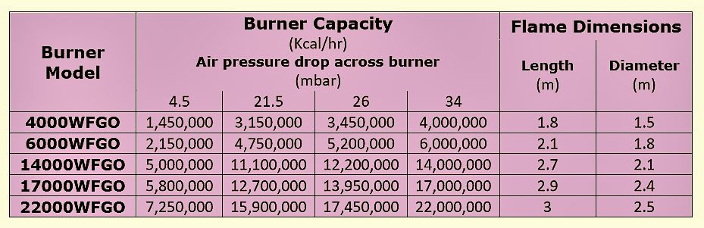
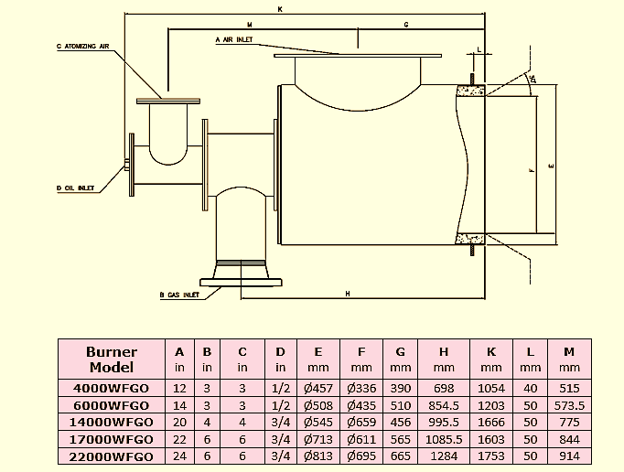
AZIN SHOLE AFROZ KIMIYA
TLE: 026-34277851 FAX: 026-34277499 WWW.ASHAK.CO.IR

• Furnace opening should be 3/4" larger than dimension F.
• After a length of 1.2 E flare out the tile at a 30O angle (60O included angle).
Installation: The burner does not include a refractory tile. The shape shown on the dimension drawing must be built into the combustion chamber wall.

AZIN SHOLE AFROZ KIMIYA
TLE: 026-34277851 FAX: 026-34277499 WWW.ASHAK.CO.IR

