RADIANT TUBE DUAL FUEL BURNER | MODEL: RG(O)

RG(O) dual–fuel burner operates with gas or light oil on multi pass radiant or immersion tubes of approximately 4~6 inch ID. Ideally, the first leg of the tube should be at least 15 tube diameters in length. Longer tubes with additional legs should provide increased fuel efficiency. Shorter tubes can usually be fired satisfactorily if the burner is adjusted for faster mixing and the desired BTU. input is not too high for complete combustion within the tube. Straight tubes can also be fired successfully. Tubes larger than 6 ID may require special modification of the burner.
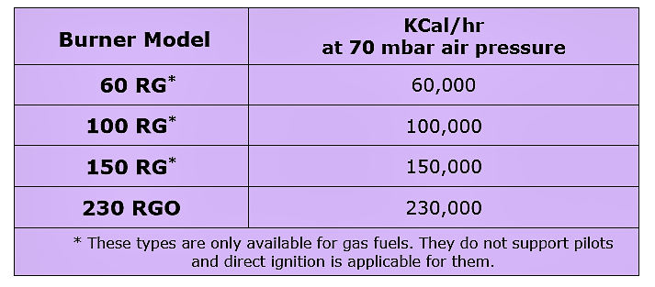

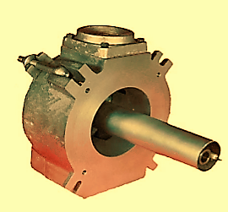

AZIN SHOLE AFROZ KIMIYA
TLE: 026-34277851 FAX: 026-34277499 WWW.ASHAK.CO.IR

REQUIREMENTS:
Atomizing air rate is 5.7 m3/hr at 70 mbar. Fuel/air ratio can usually be set to obtain an exhaust with 3% oxygen when operating on gas, and 4% oxygen when operating on oil. RG(O) burner is suitable for use with UV flame supervisory equipment.
Initial Adjustments for Dual Fuel Model:
The burner has a primary air adjustment, which is set once during the initial firing to match the flame length to the radiant tube being used. This adjustment should be made first while burning oil, since air directed through this passage reduces the main air spin, and has a greater effect on the oil flame. Then switch to gas operation and check the flame length. It should be slightly longer in appearance than the oil flame for an equivalent heat input at the same fuel/air ratio. A slight adjustment can also be reset for gas, but then readjustment will have to be made when going back to oil firing. A common adjustment for both fuels set and locked will prove to be the most satisfactory for an installation with a large number of burners.
The burner includes a small 5000 Kcal/hr built – in premix pilot assembly with center spark electrode, which is powered by a 5000 or 6000 V ignition transformer.

The pilot air-gas mixture is supplied at a pressure of approximately 30mbar from pilot mixers with cross -connected gas regulator. When manually lighting pilots, turn the main air off. Atomizing air is adjusted and left on full at all times. Pilot air is adjusted to provide proper mixture pressure. Pilot gas is then turned on, and a momentary contact push-button is used to energize the ignition transformer. When a stable pilot flame is observed on all burners, the main air is turned to high fire, and fuel valves will open automatically, lighting each main burner flame. Pilots burn continuously, while main flame is controlled high–off. For remote lighting, use the same lighting procedure with a solenoid operated pilot gas valve and a timer to turn-off the spark after a 10-second ignition period. A maintained contact push-button is used to energize the pilot valves and ignition transformer.
Operation:
Burners operate best with on/off or high-low control, and constant (or intermittent) pilot. The burner complete includes one observation port and the integral premix gas pilot with center spark electrode.

AZIN SHOLE AFROZ KIMIYA
TLE: 026-34277851 FAX: 026-34277499 WWW.ASHAK.CO.IR

RG(O) DIMENSIONS:
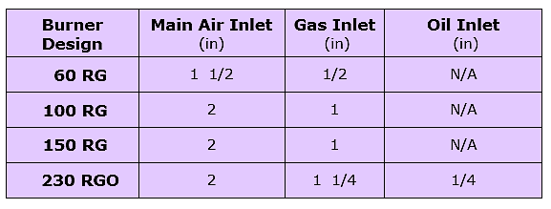
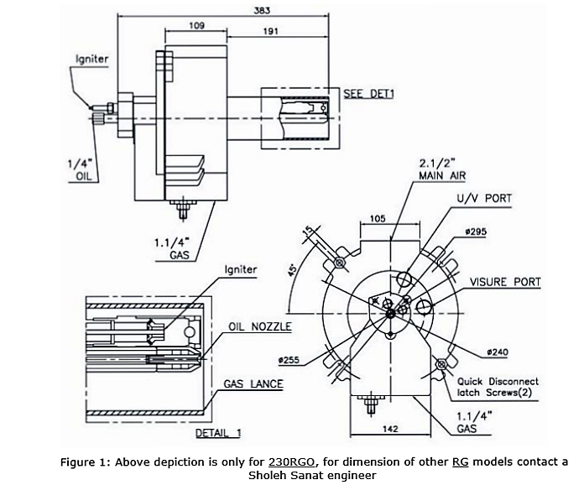
AZIN SHOLE AFROZ KIMIYA
TLE: 026-34277851 FAX: 026-34277499 WWW.ASHAK.CO.IR

