SUPER HIGH VELOCITY, MULTI-CHANNEL, MEDIUM VELOCITY GAS BURNERS | MODEL : HHG, DCHHG, HMG

HHG/C BURNER is a high velocity nozzle-mix gas burner with wide applications in heat treat and melting furnaces, air heaters, dryers, galvanizing tanks, sintering furnaces, or crucible furnaces. It would be considered that HHG burner often is easier to install than a conventional burner with tile. These burners can be used in most installations except those that exceed 900oC because the HHG/C Burner's metal tips should not be exposed directly to temperatures above 900oC. But if the tip is protected from direct radiation and if combustion air flows through the burner whenever it is at higher temperatures, appropriate furnaces, kilns, etc are not a problem. The new type of HHG with SiC (Silicon Carbide) tip –called HHG/S - can be used for higher temperatures up to 1450oC. Although these tips are more resistant to temperature shocks, they are fragile. HHG BURNER can be designed with High temperature resistance metal alloys like S.S. 310 to be used for harsh industrial environments. HHG/M BURNER is not as resistant as HHG/S in facing high temperatures but it is less fragile.
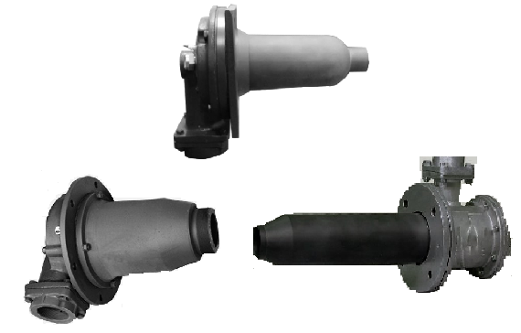
AZIN SHOLE AFROZ KIMIYA
TLE: 026-34277851 FAX: 026-34277499 WWW.ASHAK.CO.IR

FEATURES:
a) Wide operating range (with excess-air, turn-down ratio equals to 50:1)
b) High velocity & High Excess-air
c) Flame supervision
d) Simplified piping
e) Simple and reliable operation
f) Compact size
g) Up to 1450oC in HHG/S model

BURNER TYPES:

HHG burners are manufactured in ranges from 220,000 kCal/hr to 600,000 kCal/hr and in 3 different models have shown in the following table. Broadly speaking, maximum gas and air pressure needed for this burner is 70 mbar(g).
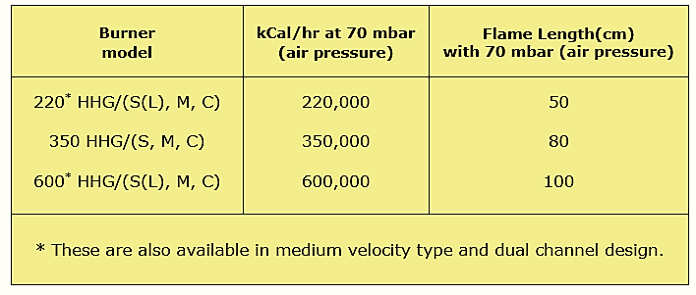

AZIN SHOLE AFROZ KIMIYA
TLE: 026-34277851 FAX: 026-34277499 WWW.ASHAK.CO.IR

HHG/(S, M, C) DIMENSIONS:
General dimensions of HHG(S, M, C) burners are as follows. For more detailed dimensions of burner or installation drawing please contact us.
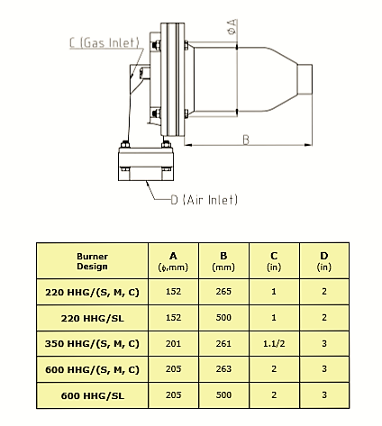

MULTI CHANNEL HHG BURNERS or DCHHG/S:
HHG/S BURNERS are also provided with extra SiC/metal tips to inject more excess air and provide more volume of POC or products of combustion. This way controlling temperature of furnaces from 50°C will be feasible more easily.
AZIN SHOLE AFROZ KIMIYA
TLE: 026-34277851 FAX: 026-34277499 WWW.ASHAK.CO.IR

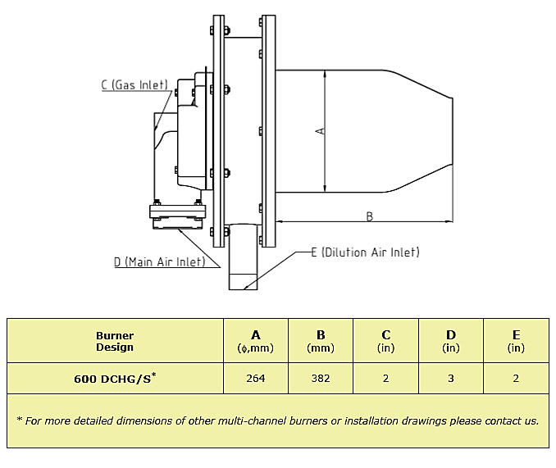

HMG/S DIMENSIONS:
HHG BURNERS are also provided with medium velocity Silicon Carbide tips. General dimensions of HMG/S burners are as follows. For more detailed dimensions of burner or installation drawing please contact us.
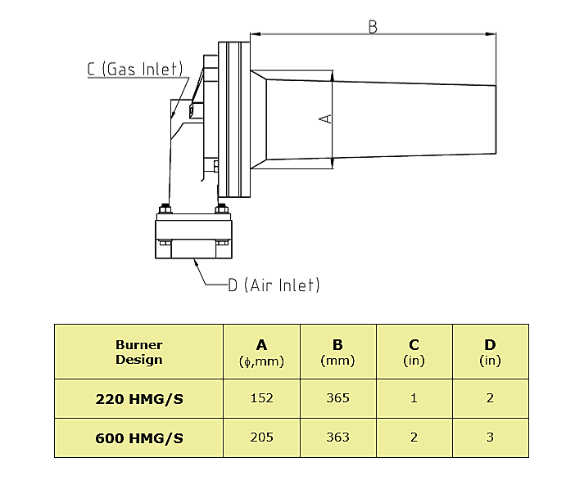
AZIN SHOLE AFROZ KIMIYA
TLE: 026-34277851 FAX: 026-34277499 WWW.ASHAK.CO.IR

OPERATION:
These burners can be lighted at rich, lean or correct air/gas ratio then immediately turned to high fire. These burners can deliver high excess air at any temperature from 100oC to 1150oC. Restricted tip exit forces hot gases to leave the burner at extremely high velocity and optimization convective heat transfer. Lights readily over a wide range of pressure and it is extremely stable.
LIGHTING/FLAME SUPERVISION
A direct spark ignition of the burner is normally used to light these burners. A standard ultraviolet (UV) or flame rod can be used for monitoring flame. With UV, the burner can operate with up to 3000% excess air which have 100 oC hot mix. With flame rods, excess air is limited to 500%, which coresponds to about 500 oC hot mix.
EXCESS AIR
Excess air improves temperature uniformity by avoiding hot spots in front of burners, churning furnace atmosphere to reduce stratification and creating positive furnace pressure to eliminate cold air infiltration. Excess air can give very high effective burner turn down. Thus a furnace used for high temperature work with burners firing on stoichiometric air/gas ratio can also be used for low temperature jobs with burners firing on lean ratio.
INSTALLATION
1-Requirements :
a) Maximum allowable inlet pressure to the gas governor is 500 mbar. If greater than 500 mbar, an upstream pressure regulator must be used.
b) Gas supply pressure to the gas governor should be at least 14 mbar greater than the high fire burner air pressure. If less, a bleeder must be installed in the impulse line.
2-Burner Mounting :
a) WARNING: Burners cannot be rotated with respect to the mounting plate as the flame detector ports must align with notches in the plate.
3-Piping :
a) Minimize piping pressure losses. Use a minimum of elbows. Substitute 45º elbows for 90º elbows when possible. Do not use street elbows. 1/4˝ tubing may be used for impulse lines up to 3 m long, 1/2˝ tubing or larger for longer runs.
AZIN SHOLE AFROZ KIMIYA
TLE: 026-34277851 FAX: 026-34277499 WWW.ASHAK.CO.IR

b) Air pipe and gas lines in a manner similar to that shown in next figure. Flexible connections are recommended in air and gas lines to minimize strain from piping and thermal expansion.
c) Connect impulse piping as shown in next figure. These piping arrangements are designed to keep air and gas flows on desired ratio at all firing rates.
d) Governors impulse line connections must be located between the zone control air valve and the manual burner air valve for multiple burner zones.

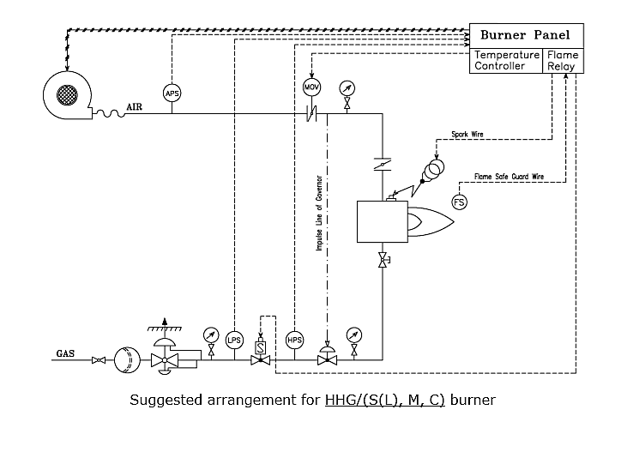

AZIN SHOLE AFROZ KIMIYA
TLE: 026-34277851 FAX: 026-34277499 WWW.ASHAK.CO.IR

