Open-Port DUAL FUEL BURNERS | MODEL: OPG (O)

OPG (O) BURNERS are nozzle-mix dual fuel burners (natural gas-heavy/light oil). The upper part of the burner is interchangeable to change the fuel. OPG (O) burners are generally used on rotary furnaces (such as cast iron and zinc melting rotary furnaces), steel preheat furnaces, aluminum and glass melting furnaces.
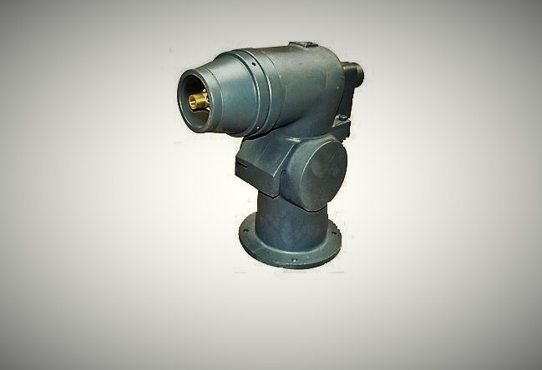
Figure: OPG Burner
FEATURES: The OPG (O) burner flame is swirl and divergent. These burners achieve oxidizing and reducing flame. The boundary around the burner port would be opened within installation and it should be considered that the flame is flowed to furnace by specified vent so it is called "open port" and it is so convenient to use on rotary furnaces. As result of swirl shape of flame, it is more resistant inside the furnace and heat transfer is appropriate by convection. Turndown ratio for gas is 4 to 1 and for liquid fuel is 3 to 1. It is so important that the gas pressure for these types of burners could be from 60 mbar to 300 mbar. (Liquid fuel pressure at burner is 300 mbar)

BURNER TYPES: OPG (O) burners are manufactured in widely range from 250,000 Kcal/hr to 4,000,000 Kcal/hr and in 6 different models have shown in the following table.
AZIN SHOLE AFROZ KIMIYA
TLE: 026-34277851 FAX: 026-34277499 WWW.ASHAK.CO.IR

Type | Kcal/hr at 60 mbar (air pressure)
250 OPG * | 250/000
1000 OPG(O) | 1/000/000
14 00 OPG(O) | 1/400/00
2000 OPG(O ) | 2/000/000
3000 OPG(O ) | 3/000/000
4000 OPG(O ) | 4/000/000
* This type is only manufactured for gasous fuels.

DIMENSIONS:
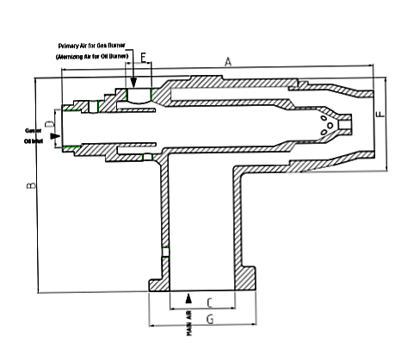
AZIN SHOLE AFROZ KIMIYA
TLE: 026-34277851 FAX: 026-34277499 WWW.ASHAK.CO.IR

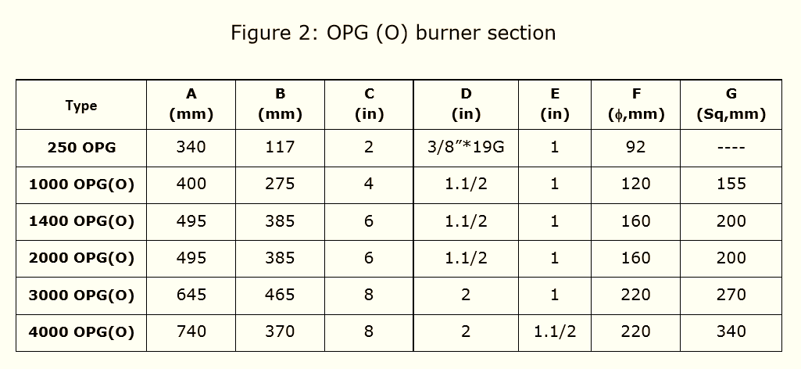
OPERATIONS:
- Oil Burner:
OPO is the forced draft oil burner. As the fuel is supplied at low pressure, the nozzles have diameters greater than one millimeter and do not easily get blocked up; thus little maintenance is required. Fuel is atomised statically by low pressure air (from blower) and oil flow is regulated by oil governor which is operated by air signal. The fanned air reaching the burner is divided into two streams: one for combustion which can be regulated, and the other for atomization which is fixed.
- Gas Burner:
OPG is the forced draft gas burner. In these types of burners, there are two air inlets: primary air (constant) and secondary air (variable with gas flow). The gas is regulated by a governor based on air signal after actuator.
INSTALLATION:
1-Requirements:
a) Maximum allowable inlet pressure to the gas governor is 500 mbar. If it is greater than 500 mbar, an upstream pressure regulator must be used.
b) Gas supply pressure to the gas governor should be at least 14 mbar greater than the high fire burner air pressure. If less, a bleeder must be installed in the impulse line.
AZIN SHOLE AFROZ KIMIYA
TLE: 026-34277851 FAX: 026-34277499 WWW.ASHAK.CO.IR

c) Fuel oil must be supplied to the oil governor at 3 bar. Oil should be supplied from a circulating system controlled by a diaphragm relief valve or regulator.
d) Atomizing air pressure at burner must be at least 70 mbar.

2-Burner Mounting:
a) Burners should be mounted with air, gas, pilot, and UV connections on the top or side to prevent oil dripping into them.
b) WARNING: Burners cannot be rotated with respect to the mounting plate as the pilot and flame detector ports must align with notches in the plate.
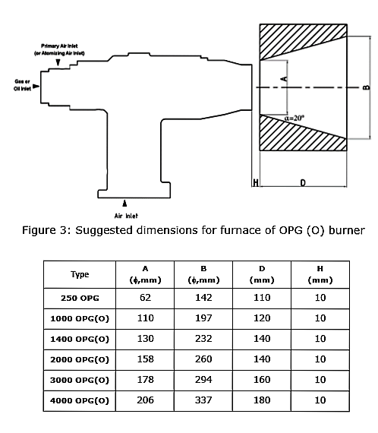
AZIN SHOLE AFROZ KIMIYA
TLE: 026-34277851 FAX: 026-34277499 WWW.ASHAK.CO.IR

3-Piping:
a) Minimize piping pressure losses by using minimum of elbows. Substitute 45º elbows for 90º elbows when possible. Do not use street elbows. Use pipe (not tubing) for pilot air and gas lines. 1/4˝ tubing may be used for impulse lines up to 3 m long, 1/2˝ tubing or larger for longer runs.
b) Pipe air and fuel lines in a manner similar to that shown in Figure 4. Flexible connections are recommended in air and fuel lines to minimize strain from piping and thermal expansion.
c) Pilot air, gas and atomizing air supply connections must be made upstream of primary burner controls so that they are not affected by the zone air control and gas shutoff valves.
d) Connect impulse piping as shown in Figure 4. These piping arrangements are designed to keep air and gas flows on desired ratio at all firing rates.
e) Ratio regulator impulse line connections must be located between the zone control air valve and the manual burner air valve for multiple burner zones and downstream of the manual burner air valve for single burners.

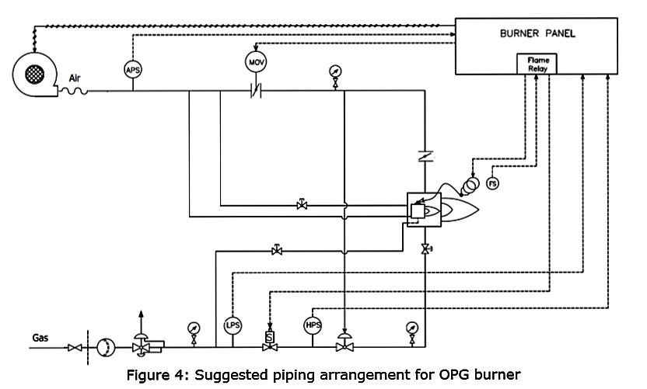

AZIN SHOLE AFROZ KIMIYA
TLE: 026-34277851 FAX: 026-34277499 WWW.ASHAK.CO.IR

