FLAT FLAME DUAL FUEL BURNER | MODEL: 200FGO

FLAT FLAME DUAL FUEL BURNER
• Gain Heating Uniformity
• 12:1 Turndown or more
• Eliminate Flame Impingement
• Clean Combustion, Gas or Oil
• Field-proven, long-life Refractory
• Simple Mounting, Any construction
200 FGO burner provide a radial flame pattern that reduces hot-spotting and permits larger loadings of furnace or lehr. They include stable pilot for reliable light/off and fewer nuisances Shutdown. Clean combustion with virtually no carbon buildup gives greater efficiency on gas or oil. Standard scanner connection with provision for cooling/purge air gives excellent flame supervision reliability. Wide turndown means better temperature control without over-ride. The field-proven, long-life burner block gives long service life and so reduces downtime. Rated capacities are based on only 60mbar. Differential combustion air supplies pressure. There is no need for high pressure atomizing air supplies, and with careful system design, a single 70mbar.blower may be adequate. Mounting flexibility allows you to install 200FGO burner in sidewall, through refractory, thin wall, soft wall or panel type construction. Standard refractory material permits operation at firing chamber temperatures of up to 1200oC.
AZIN SHOLE AFROZ KIMIYA
TLE: 026-34277851 FAX: 026-34277499 WWW.ASHAK.CO.IR

Accessories
Adjustable valves simplify start-up and adjustment when two or more burners share a common control valve.
Seal & Support housings are available to provide additional support to burner block, giving longer life in thin wall or soft wall installations. A complete 200 FGO burner system will also include gas and/or oil trains, air/fuel proportioning equipment, pressure blower, and a control panel. Capacities/Specifications
Capacities and operating data are shown in the table below for 200 FGO burner. Figures are based on firing with natural gas and # 2 fuel oil.
Gas pressures shown are " differential " (firing chamber to burner test connection). Propane may be fired at approximately 40% of the pressure shown for natural gas.
Oil supply must be regulated to the pressure indicated at the inlet to burner, and must be maintained at 5 C 0 or higher (50SSU minimum viscosity).
Atomizing air is required for oil firing. Shutting off atomizing air for gas firing gives lower minimum capacities at the expense of slightly reduced maximums.
Burner mounting should be such that discharge face of block is either flush with wall or protrudes a maximum of 1" .Do not recess block in wall. Center-to-center mounting distance between burners should never be less than the maximum flame diameter shown.
Multiple burner installations should be provided with adjustable valves in the fuel and air- lines to each individual burner.

WARNING: Use only UV flame sensor systems for oil firing Test every installation for dangerous spark excitation from ignitors and other burners as well as other possible sources of direct or reflected UV radiation.

Assembly Number
Assembly numbers for 200 FGO burner configuration and accessory/replacement (A/R) items are provided in the table, as well as approximate shipping weights for complete burner. Bruner with seal and support housing may be specified with an optional mounting ring which is welded in place at assembly to give desired block placement relative to inner firing chamber wall. If you do not specify a
AZIN SHOLE AFROZ KIMIYA
TLE: 026-34277851 FAX: 026-34277499 WWW.ASHAK.CO.IR

desired mounting ring location, it will be shipped "loose”, requiring welding at installation.
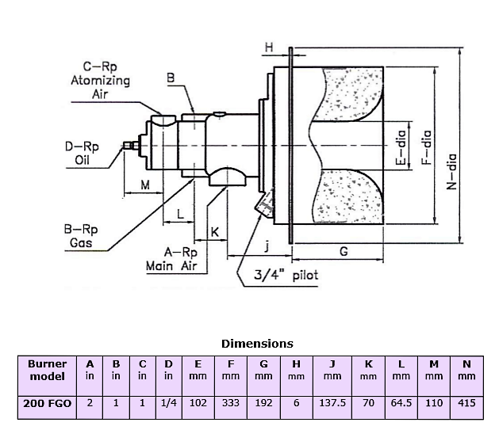
AZIN SHOLE AFROZ KIMIYA
TLE: 026-34277851 FAX: 026-34277499 WWW.ASHAK.CO.IR

General Notes
Dimensions for 200 FGO burner are shown below. Seal and support housing includes a welded mounting ring which is mounted at a location specified by you (and within the allowable range shown) to match wall thickness. If you do not specify position, ring will be shipped "loose" requiring welding at installation. In any case, we strongly suggest using actual ring as a template to locate studs/fasteners. Block face should be installed flush with inner furnace wall. Do not recess. Opening in furnace wall should be cut to give ½” clearance at any point.
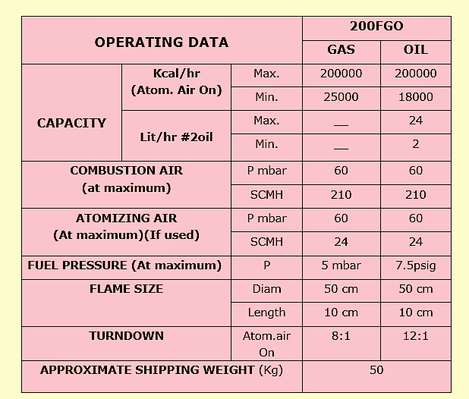

AZIN SHOLE AFROZ KIMIYA
TLE: 026-34277851 FAX: 026-34277499 WWW.ASHAK.CO.IR

Installation Instructions
General: 200 FGO burner is only a part of a complete combustion system. They can fire in any direction, but the scanner manufacturer may impose limitations. Use flexible connections in all piping to reduce piping stresses and alignment/shifting problems. "Level" down-firing burners carefully during installation for best performance. Include observation ports in your design to provide view of both main and pilot flame areas. Start-up and adjustment procedures will be greatly simplified.
Piloting: Pilot should be interrupted, whether the main flame is gas or oil. If operation calls for oil firing only, pilot may be fed by bottled gas. Select piping size for the usage indicated in capacity table.
Flame sensing: Burner design incorporates UV scanner port suitable for supervision of both pilot and main flames. Use of purge/cooling air is recommended.

WARNING: Test every UV installation for dangerous spark excitation from ignitors and other burners, as well as other possible sources of direct UV radiation

Oil Piping: Use oil adjustable valves (located as close to the burner as possible) to equalize flows on multiple-burner installations and (if necessary) to increase the upstream pressures required.
Run all oil piping below the burner centerline wherever possible. On down firing jobs this means getting the oil piping down below the burner oil inlet and if possible, Over the side of the furnace.

Gas Piping: Use gas adjustable valves as outlined above for oil. Install gas cocks near each burner on multiple-burner jobs. Close them during oil firing to prevent recycling of oil vapors between burners.

Air Piping: Install and use main and atomizing air adjustable valves as outlined above for oil. Size air piping carefully to give the full flows and pressures needed. Install constant purge air to scanner port. Sketch 1 below summarizes the additional components that might typically be part of a complete system. Use this sketch and the following comments as checklist prior to actual installation.

AZIN SHOLE AFROZ KIMIYA
TLE: 026-34277851 FAX: 026-34277499 WWW.ASHAK.CO.IR

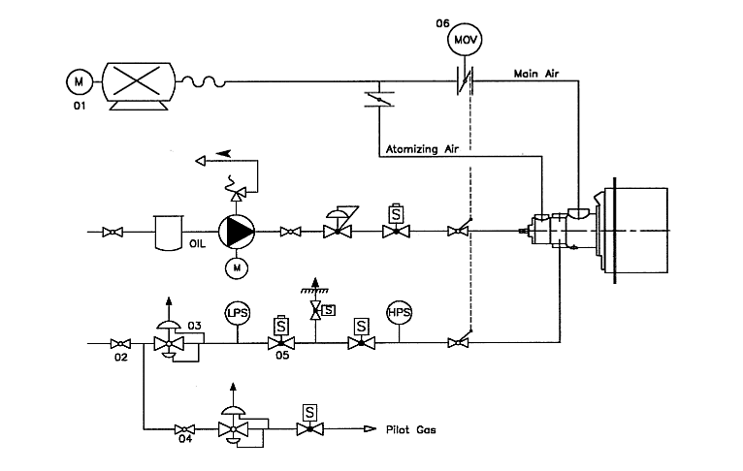

1.Combustion air blower (1) provides the air supply to your combustion system and is essential to the inspiration and mixing of fuel gas. Locate it in the coolest, cleanest position that you can find near the burner itself. It must not be exposed to direct radiant heat or positioned where it might draw. In the inert gases or hot air rising from a furnace or oven, if problems exist, consider filters, relocation and/or ducting of an outside air supply.
2.Electrical service must match the voltage, phase and cycle of all electrical system components. Verify that all normal control sequences and functions are adequately performed.
3.Supply piping for fuel must be large enough to maintain required fuel pressure at the adjustable valve inlet with burner at full capacity. Excessive length, too many piping turns or the use of non- standard gases may necessitate "over sizing" to keep pressure drops acceptable. Atomizing airline must be large enough to maintain required flow and pressure.
AZIN SHOLE AFROZ KIMIYA
TLE: 026-34277851 FAX: 026-34277499 WWW.ASHAK.CO.IR

4.Clean fuel lines are essential to prevent blockage of pipe train components or burner ports. Blow all dirt, scale and pipe dope out of any new gas line before actually connecting to burner system.
5.Main shut-off cock (2) should be upstream of both main gas regulator and pilot take-off .Use it to shut off pilot and main burner fuel during shutdown periods of more than a few hours.
6.Main gas regulator (3) is essential to maintain a uniform system supply pressure. Size the regulator for full system capacity at required pressure, including pipe train losses. During installation, follow the instructions attached to the regulator and be sure to remove any shipping pin or block.
7.Pilot take-off (4) should be upstream of main gas regulator but downstream of main gas cock. It should normally include its own pilot gas regulator, a solenoid valve and shut-off cock. An adjustable gas valve at the pilot inlet simplifies adjustment.
8.Fuel shut-off valves (5) (when properly connected to a safety control system) shut the fuel supply off when a hazardous operating condition is sensed. Manual reset valves require operator attendance each time the system is started up (or restarted after a trip-out). Motorized shut-off valves permit automatic start/Restart when used with an appropriate control system.
9 Fuel control valve (6) controls heat release by throttling gas, air and oil flows to burner. It should include provision for an adjustable minimum and throttling over a turndown range that matches burner capabilities.
10. Minimize (and equalize) pressure drop between adjustable valve and burner(s). 11.Burner installation should incorporate these suggestions: All fuel and air piping should be independently supported. Flexible connections are suggested. The opening in furnace shell should normally provide ½” clearance on all sides, and the burner face mounted flush with inner furnace wall or roof (definitely not protruding more than 1") .Do not recess burners. High-temperature gasket should be used between burner mounting flange and furnace shell.
For maximum burner life, burner frame and furnace shell must be protected from hot gas flows. In a refractory wall or roof, basic burner may be used (with cast able refractory rammed into a Clearance left around burner and the remaining gap packed with ceramic fiber insulation), supported with angle iron and retained by mastic-coated anchors.
In a "soft" wall or roof, burner should be specified with seal and support housing and wrapped tightly in fiber blanket. Remaining space should be packed with ceramic fiber insulation.

AZIN SHOLE AFROZ KIMIYA
TLE: 026-34277851 FAX: 026-34277499 WWW.ASHAK.CO.IR

12. Test connections are essential for burner adjustment. Each burner includes air and Fuel test connections but it is better additional connections are provided downstream of the regulator and adjustable valve. Test connections in elbows or tees should be oriented at 90 to the plane formed by piping leading in and out of that elbow. Test connections must be plugged except when readings are being taken.
13.Vent dampers and pressure controllers should be used to maintain balanced or slightly positive furnace pressures for maximum efficiency. Excessive backpressure can damage furnace and/or reduce burner capacity. Negative pressures allow infiltration of secondary air and can seriously affect efficiency and temperature uniformity.

AZIN SHOLE AFROZ KIMIYA
TLE: 026-34277851 FAX: 026-34277499 WWW.ASHAK.CO.IR

